**Q 1)** ⟹ **Create the dashboard following the general requirements In the dashboard following sheets required.**

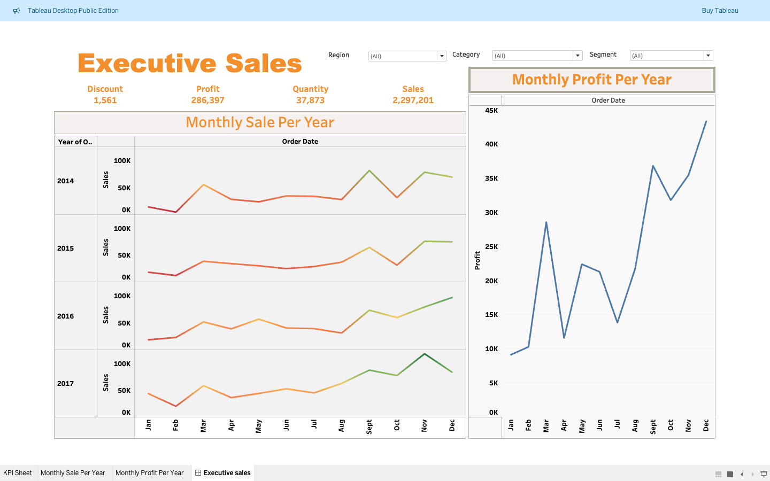

1. **The first sheet should have a total discount, profit, quantity and sales (KPI format preferred means only number- no chart).**

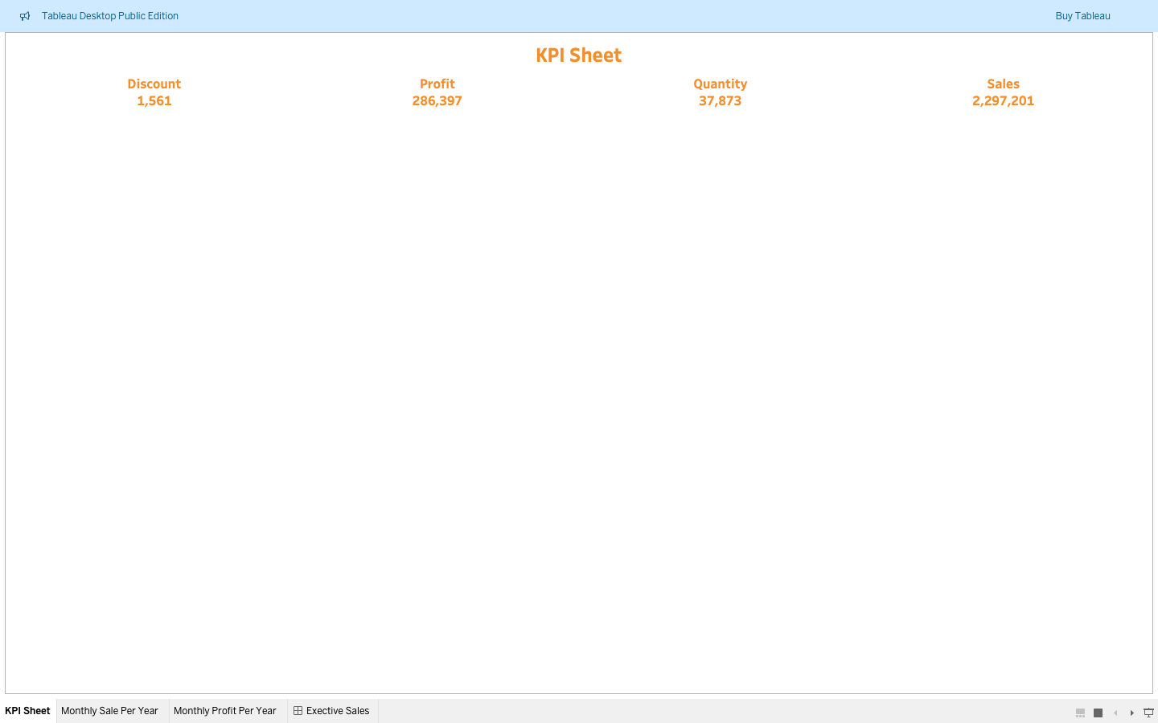

1. **The second sheet shows monthly sales per year.**

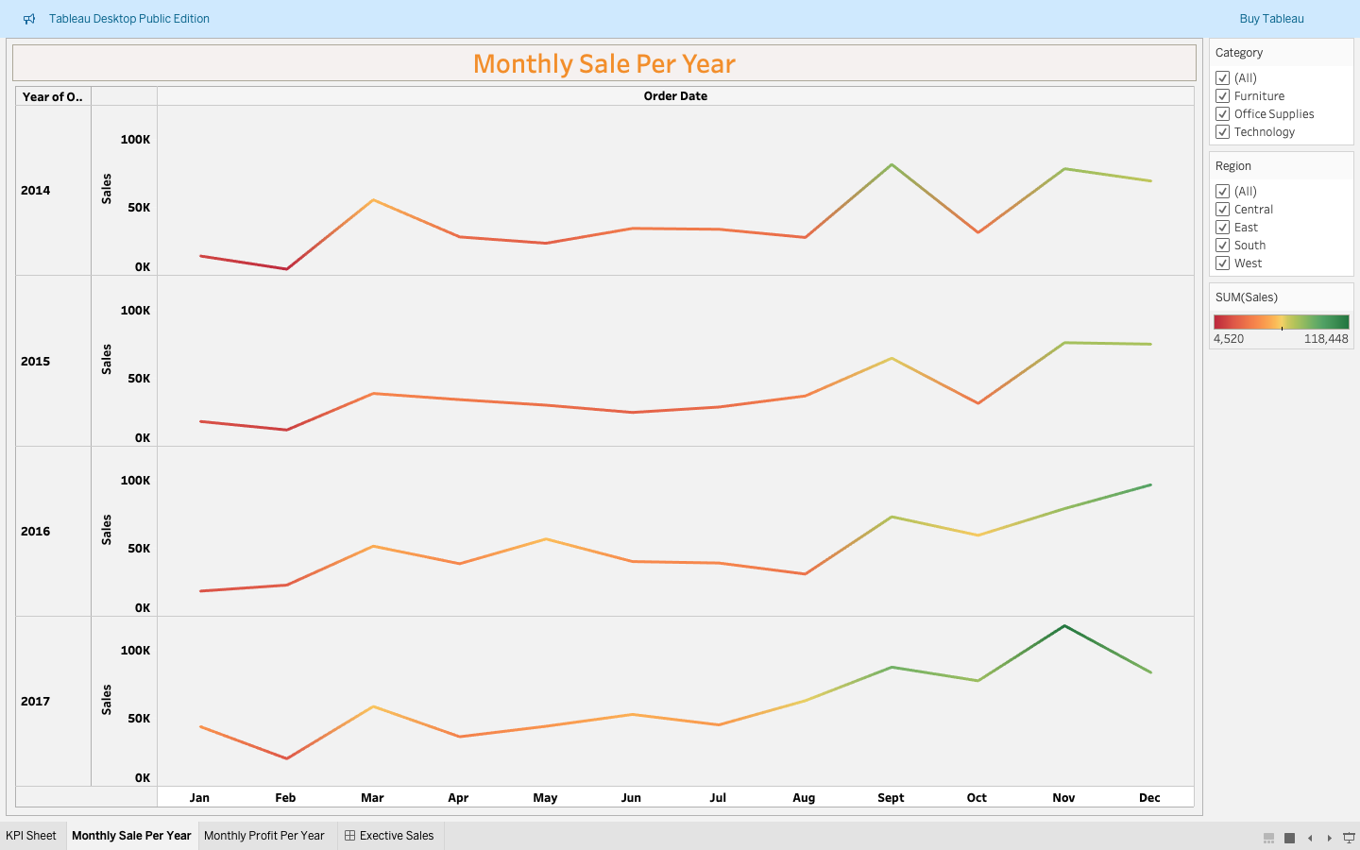

1. **The third sheet shows the monthly profit per year.**

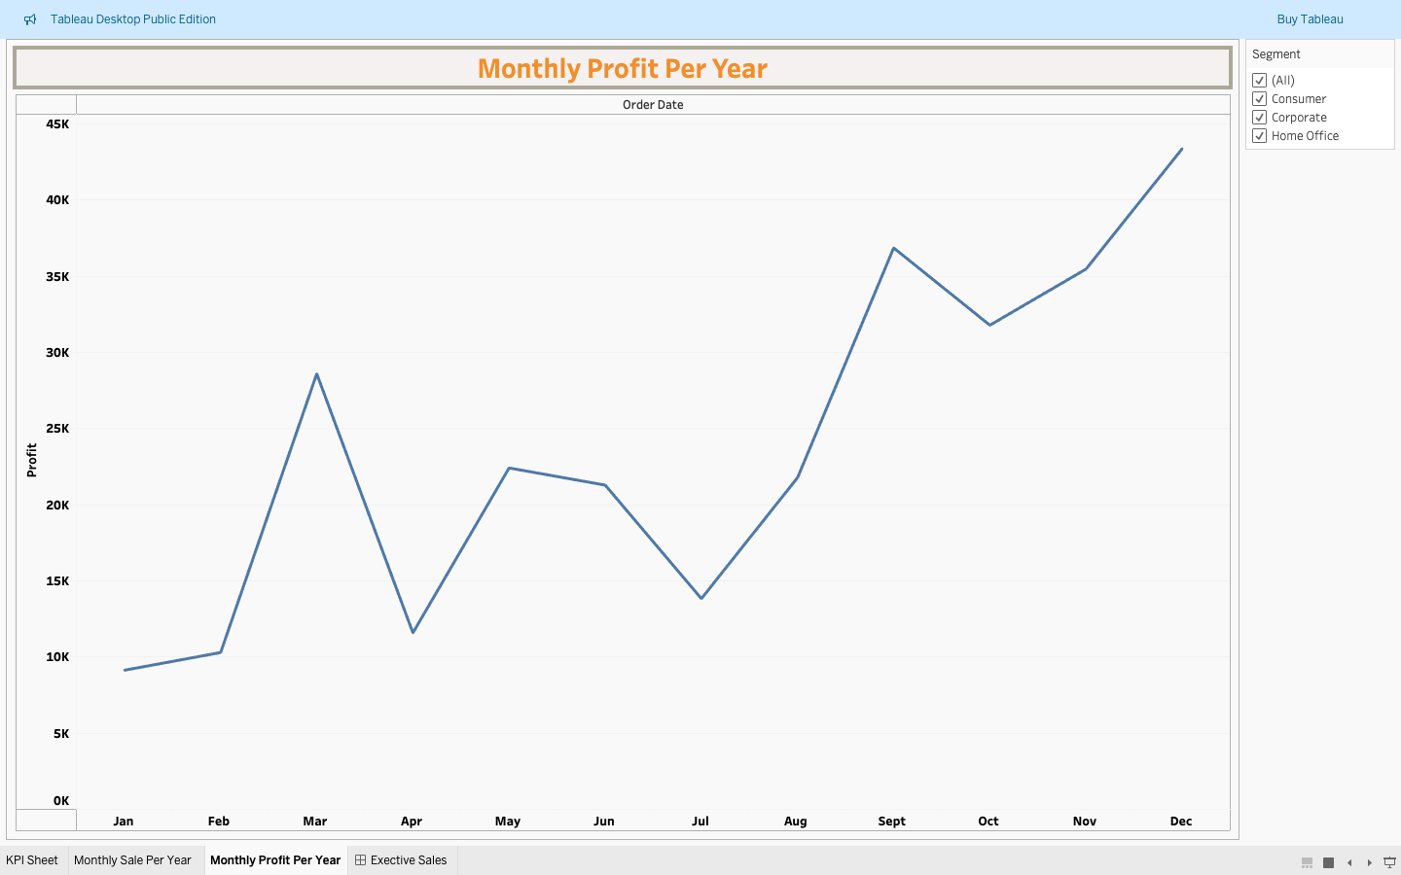

**Q 2)** ⟹ **Answer the following questions**.

**1) Top 5 cities that bear a maximum loss.**

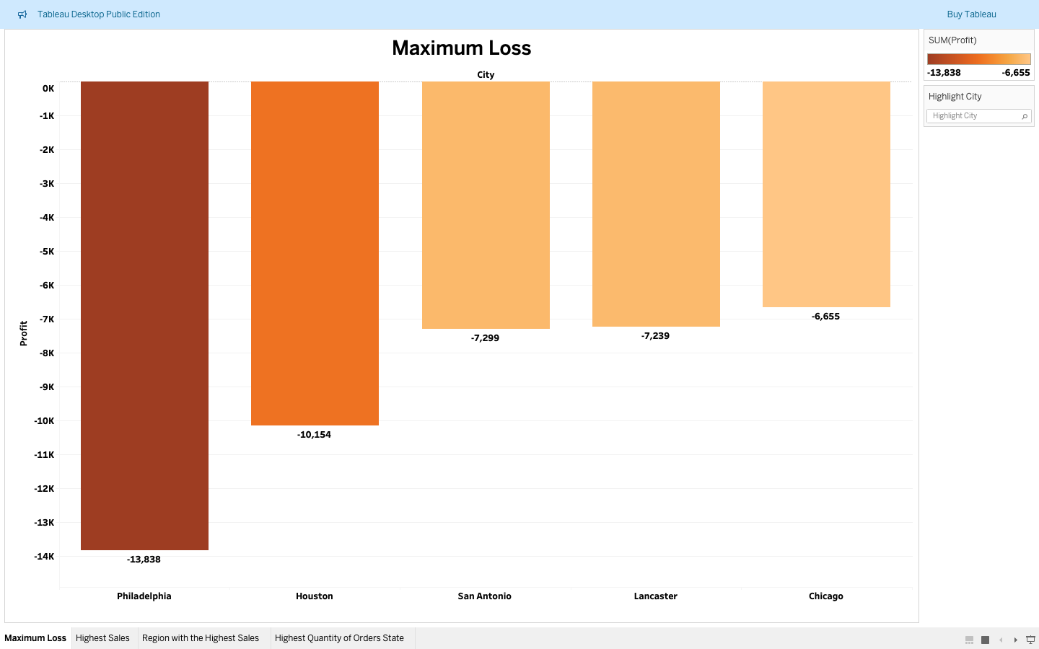

**2) Which is the region with the highest sales?**

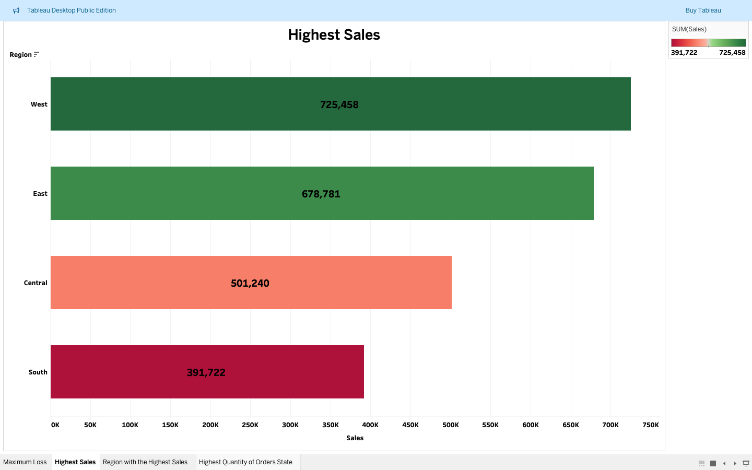

**3) Name the category in the region with the highest sales**.

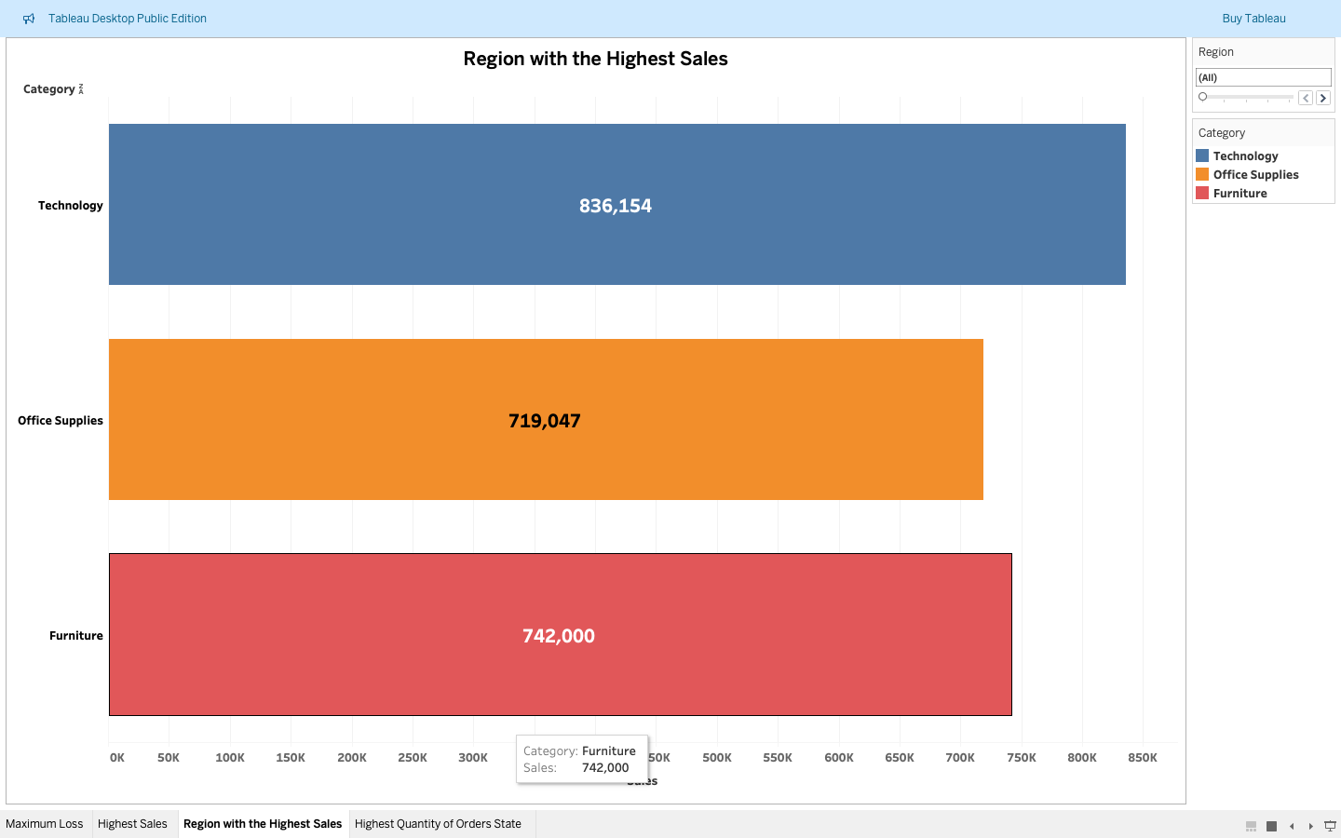

**4) Which state has the highest quantity of orders?**

